Activity 2.2 Perspective Sketching

Introduction
If you can stand on a straight road and look down the road, it appears as if the sides of the road eventually narrow to one point. The center of the road vanishes when the road meets the horizon. If the road is straight enough and long enough, the sides of the road not only look like they are converging to a single point, but the road seems to appear to vanish as it meets the horizon. A similar effect occurs if you stare upward from the base of a tall building. The vertical edges of the building will appear to angle in toward each other. This effect is called perspective.

The human eye sees the world in perspective. Objects that are further away from the eye appear smaller, and edges appear to recede into the distance. Perspective sketches depict objects in much the same way that the human eye sees the world.

There are three different types of perspective drawings: one-point, two-point, and three-point perspective. The different types of sketches are frequently used by architects, industrial designers, and illustrators when representing large-scale objects or environments in which the effect of distance must be taken into consideration.

In this activity, you will practice your sketching skills by generating perspective views based on provided isometric views of objects. You will also apply your skills by creating one-point and two-point perspective sketches of other imagined or real objects that you choose.

Equipment
- Grid paper or engineering notebook
- Pencil and/or pen
- Puzzle cube pieces
- Various objects

Procedure

1. Study the object represented in the isometric views below. Use the vanishing point and horizon line indicated to lay out light construction lines and create a one-point perspective sketch of the object within the given box. The perspective sketch must show the object in a top, left-side, front view orientation. Delineate the visible edges of the sketch with heavy object lines. DO NOT ERASE YOUR CONSTRUCTION LINES. Add tonal shading to the sketch when finished.
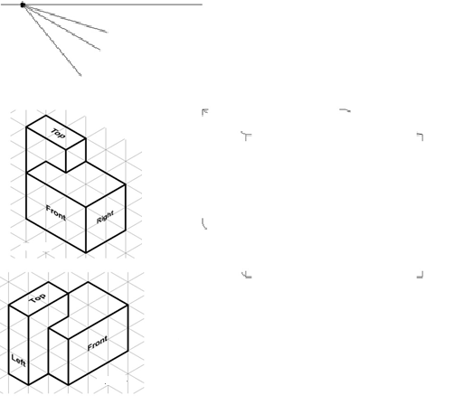

- Use the horizon line and vanishing points shown to lay out a two-point perspective sketch of the object shown in item 1 using construction lines within the given box. The perspective sketch must show the object in a top, front, right-side view orientation. Delineate the visible edges of the sketch with heavy object lines. DO NOT ERASE YOUR CONSTRUCTION LINES. Add tonal shading to the sketch.

- Create a one-point perspective sketch of a puzzle cube piece in your engineering notebook (as directed by your instructor) using pencil to create construction lines. Use ink to delineate the object lines and add tonal shading.
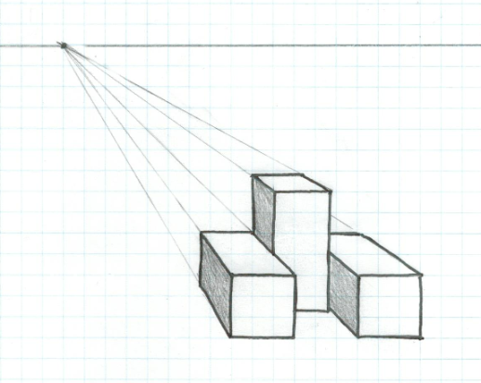

- Create a two-point perspective sketch of the same puzzle cube piece (used in item 3 above) in your engineering notebook (as directed by your instructor) using pencil to create construction lines. Use ink to delineate the object lines and add tonal shading.
- Select one of the following objects and create a one-point or two-point perspective sketch on grid paper or in your engineering notebook (as directed by your instructor). Shade the sketch.
- Highlighter, marker, etc.  - Clothespin  - Flash drive  - Flashlight  - Coffee cup  - Toothbrush  - Monitor  - Surge protector | - Cell phone, iPod, iPad, Kindle, or similar item  - Printer  - Remote control device  - Other object approved by your instructor | 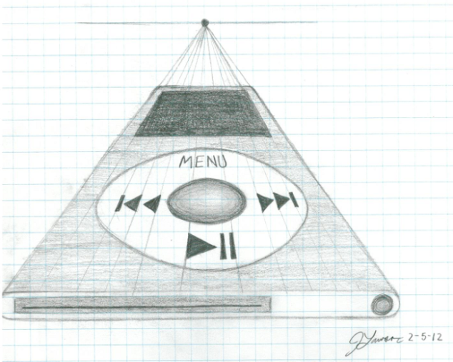

Conclusion Questions

- What is a vanishing point?

- Aside from the number of vanishing points, what is the difference between a one-point, two-point, and three-point perspective sketch?

- How does a perspective drawing differ from an isometric drawing of the same object? When would you use a perspective view in lieu of an isometric drawing?

