Activity 2.4 Multiview Sketching

Introduction
It’s a very common occurrence to see a product advertisement and think, “I thought of an idea for something like that just a few months ago.” People spend a lot of time in their various interest areas and envision ideas for making things work better. Spend some time with someone who has a permanent disability and see how many product ideas come to mind that would provide a degree of freedom to a person who has lost a physical capability. Coming up with wonderful ideas are only the first step in developing solutions to problems. At some point, ideas must be built.

You’ve practiced different techniques for sketching objects so that they appear to have a three-dimensional quality. These techniques are excellent for quickly communicating ideas to both technical and nontechnical people. Those who make their living building ideas require a different type of drawing format. A multiview sketch, also referred to as an orthographic projection sketch, is the standard sketch format used by engineers to communicate ideas to professionals in the building trades.

However, pictorials do not provide accurate information about the true size and shape of an object and all of its features. It is often the case that engineered objects have features and edges that are obscured by the standard surface views of a multiview drawing. These views require hidden lines. When engineers create drawings of cylindrical objects, or objects that have holes, they must represent their axes and axes points with centerlines.

Knowing how to sketch and interpret multiviews is an important skill for any engineer. In this activity, you will develop your ability to see and sketch objects as a series of related two-dimensional views. Understanding and using the different line conventions, discussed earlier in this lesson, will help when creating these views.

Equipment
- Pencil
- Engineering notebook

Procedure

- Study the images that follow. The various surfaces of the object are identified by letters on the isometric drawing and by numbers on the multiview drawing. In the table, write the number that corresponds with the lettered surface in each of the top, front, and right-side views.

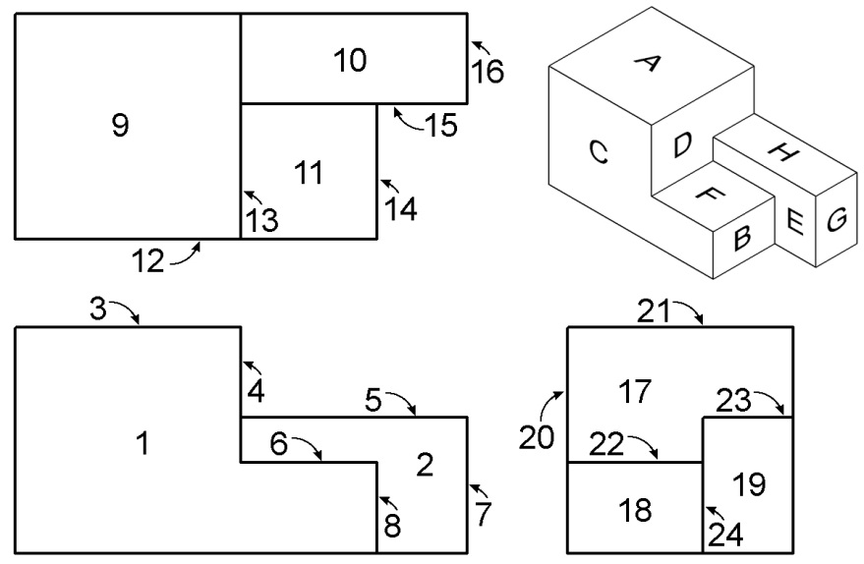 |  | Top | Front | Side
 | A | 9 | 3 | 21
 | B
 | C
 | D
 | E
 | F
 | G
 | H

- For each of the objects that follow, select the face that would provide the best front view. Then create a quick sketch of the orthographic projection showing your selected view in approximate proportions. Finally, determine the minimum number of views required to adequately represent the object and indicate the views (in addition to the front view that you would use to represent the object.
Object | Front View Sketch
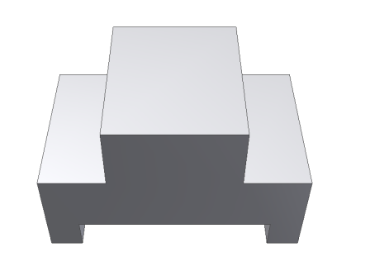
Minimum number of views: | Additional orthographic views to include:

Object | Front View Sketch
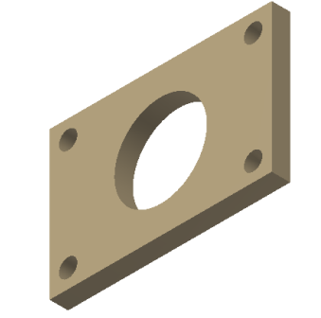
Minimum number of views: | Additional orthographic views to include:
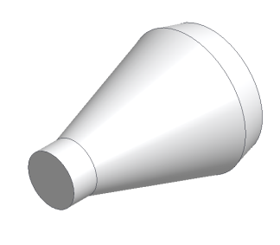
Minimum number of views: | Additional orthographic views to include:
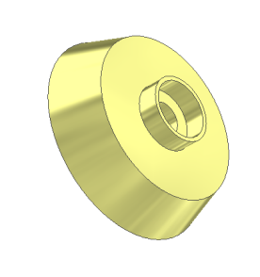
Minimum number of views: | Additional orthographic views to include:

Object | Front View Sketch
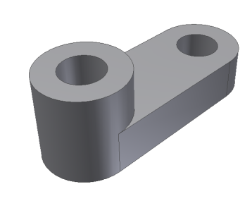
Minimum number of views: | Additional orthographic views to include:
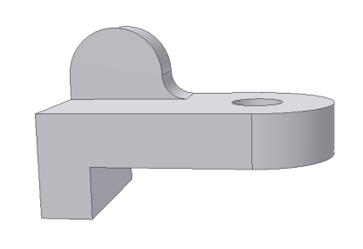
Minimum number of views: | Additional orthographic views to include:

Study the isometric views on the next four pages. Use points, hidden lines, construction lines, and object lines to sketch the three common views used to explain the object. The scale is 1:1, which means that each grid line on the isometric view represents a grid line on the orthographic grid. DO NOT ERASE YOUR POINTS AND CONSTRUCTION LINES.

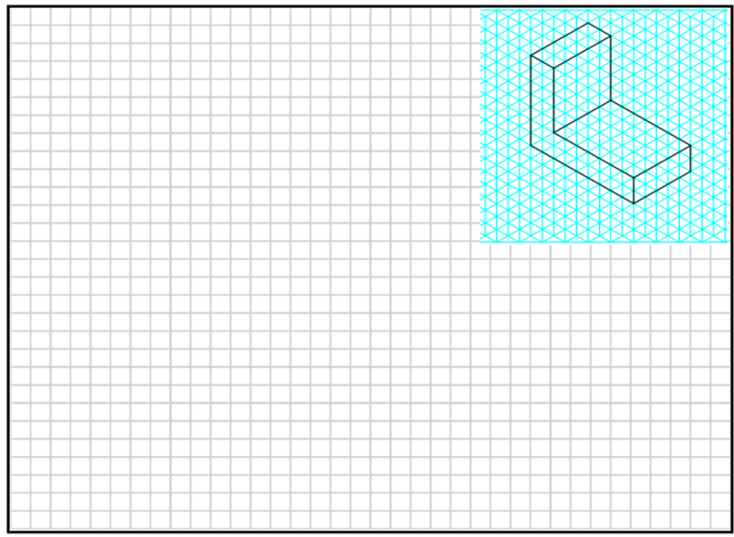

4.
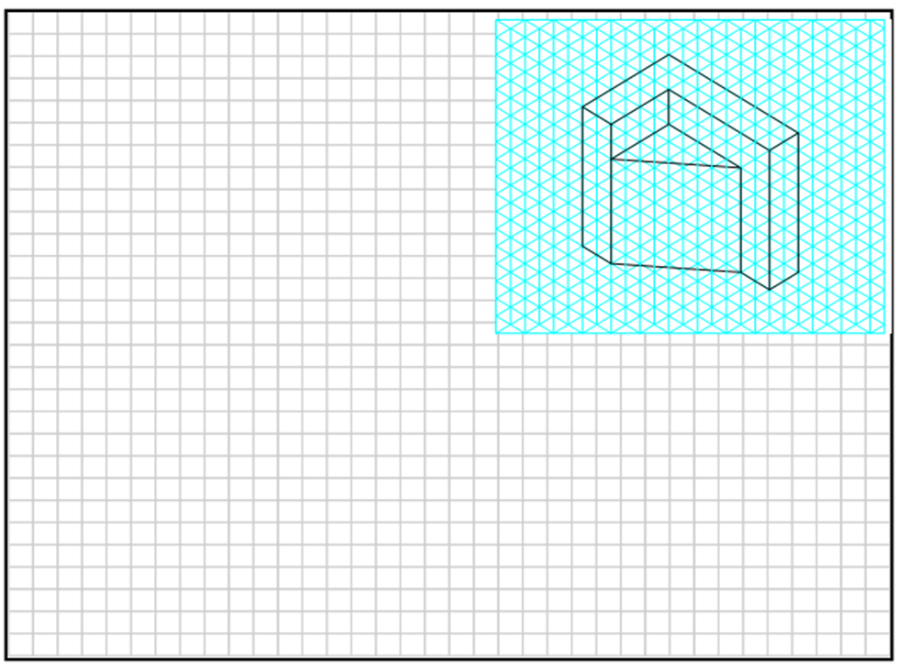

5.
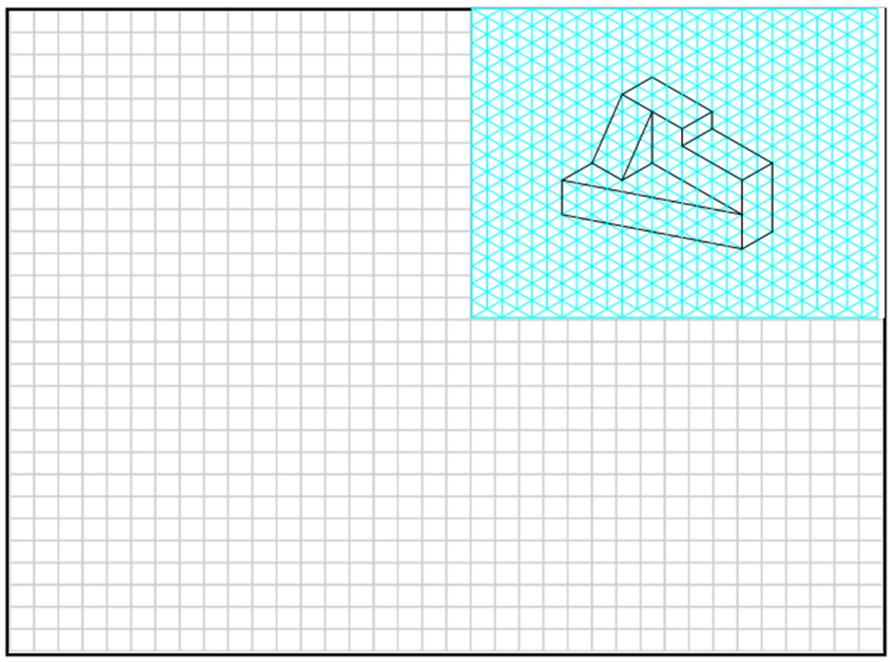

Extend Your Learning
For each of the following, create properly aligned orthographic projections on grid paper. Use the minimum number of orthographic projections necessary to fully describe the object shown. Include object lines, hidden lines, and center lines in all views, as appropriate. The sketches should be approximately proportional, but are not required to be drawn to scale.

6.  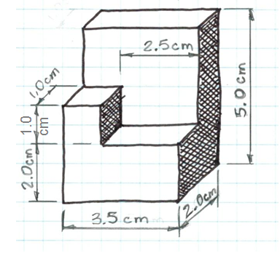 | 7.  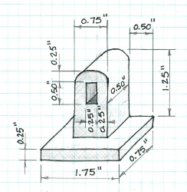 | 8.  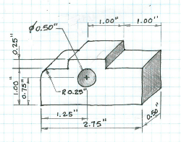

Conclusion Questions
- What is the purpose of construction lines? Object lines?

- What is the purpose of hidden lines and center lines?

- What type of pictorial is shown in the first representation in item 2? How can you tell?

- What type of pictorial view is shown in item 6? How can you tell?

- Why would building professionals, such as machinists and contractors, prefer multiview drawings over pictorial drawings?

