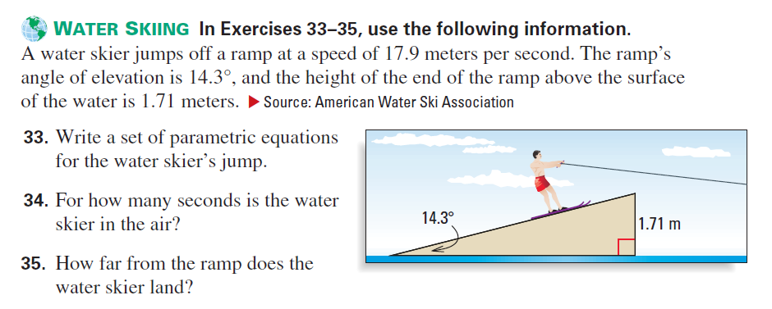
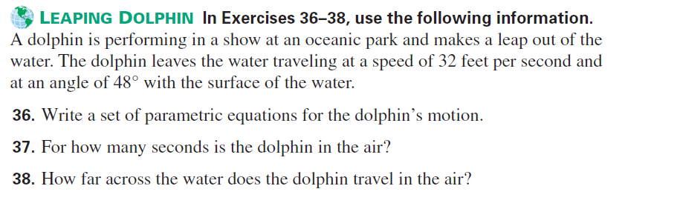
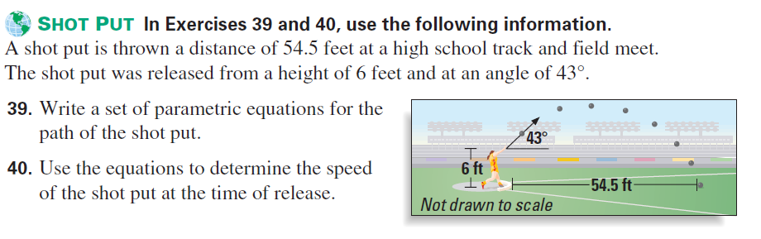

- Determine the length of the parametric curve given by the following parametric equations.

$$x=3\sin{t}$$
$$y=3\cos{t}$$
$$0≤t≤2π$$

- Use the arc length formula for the following parametric equations.
$$x=3\sin{t}$$
$$y=3\cos{t}$$
$$0≤t≤2π$$

_{Solutions:}
_{33.} $x=17.9t\cos\left(14.3\right), y=1.71+17.9t\sin\left(14.3\right)-4.9t^{2}$
_{34.} $1.19$_{sec}
_{35.} $20.6$ _{ft}
_{36.} $x=32t\cos\left(48\right), y=32t\sin\left(48\right)-16t^{2}$
_{37.} $1.49$ _{sec}
_{38.} $31.9$ _{ft}
_{39.} $x=vt\cos\left(43\right), y=6+vt\sin\left(43\right)-16t^{2}$
_{40.} $39.64$ _{ft/sec}
_{1.} $6π$
_{2.} $18π$

